How to create an Azure storage account?

* Go to https://azure Microsoft.com

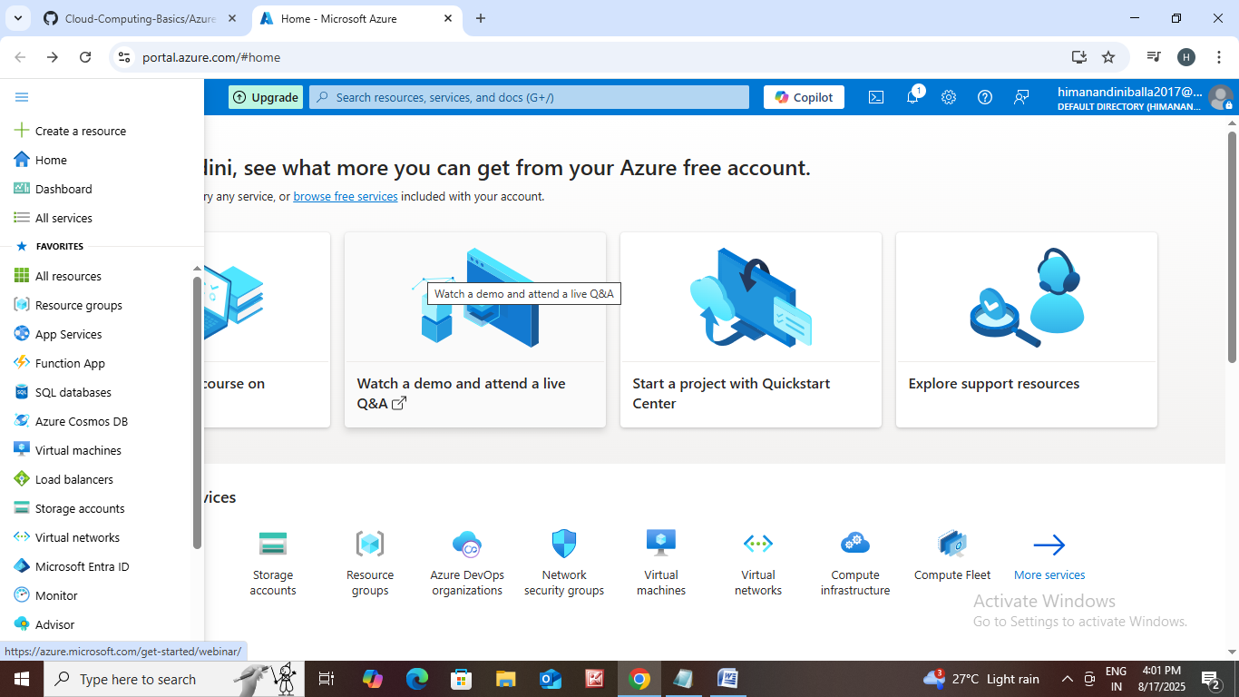

* Click on all services.

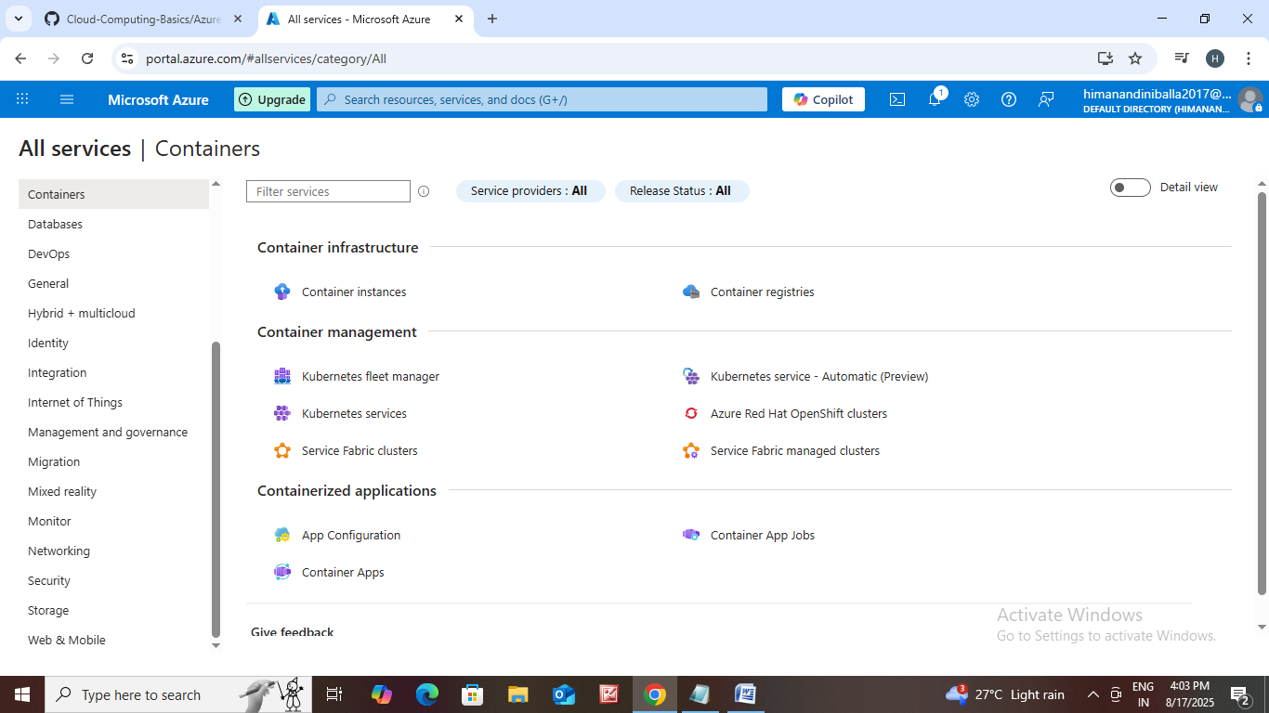

* Next click on storage.

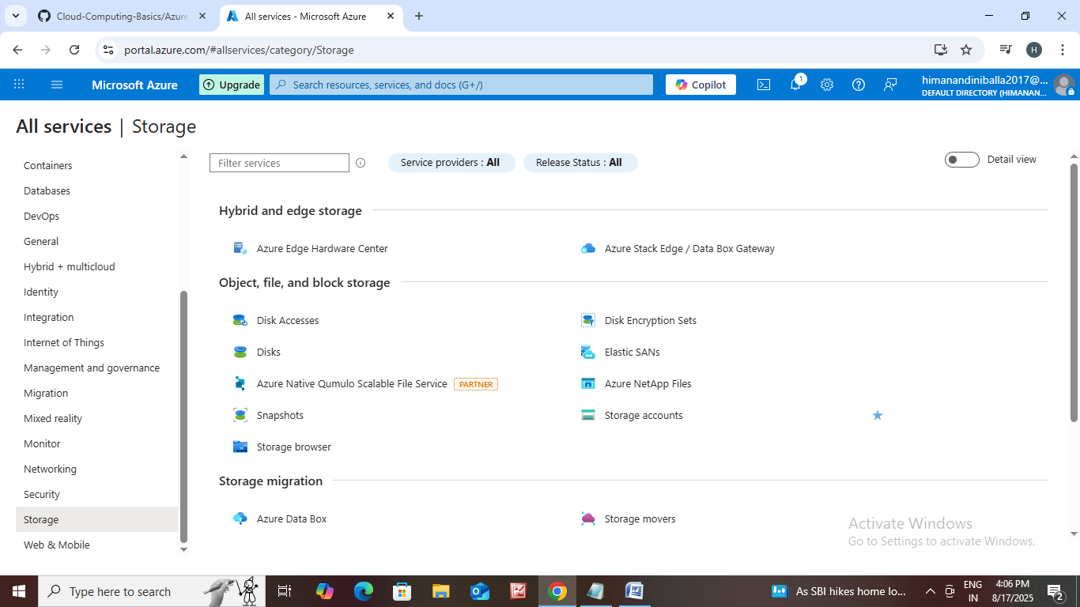

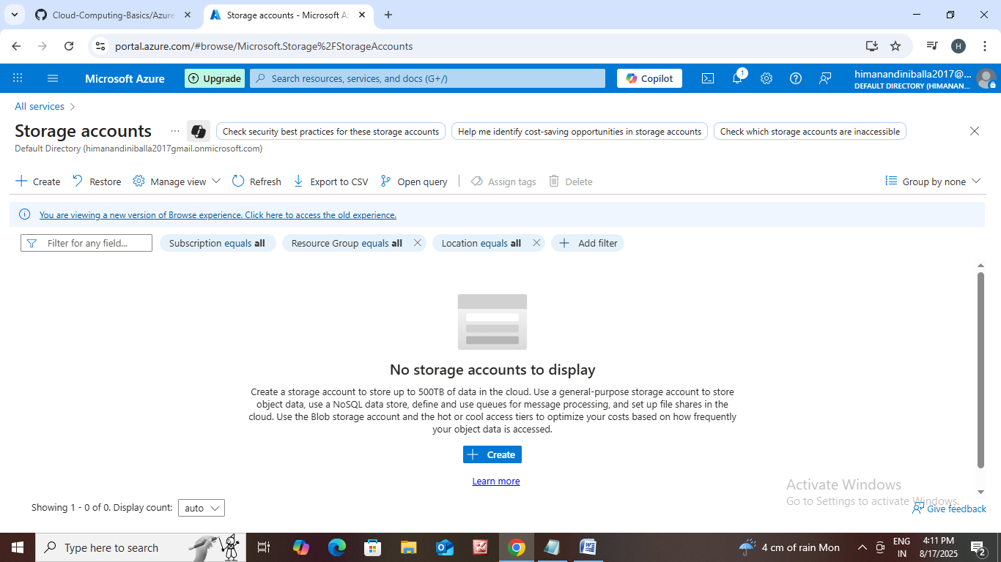

* Click on create.

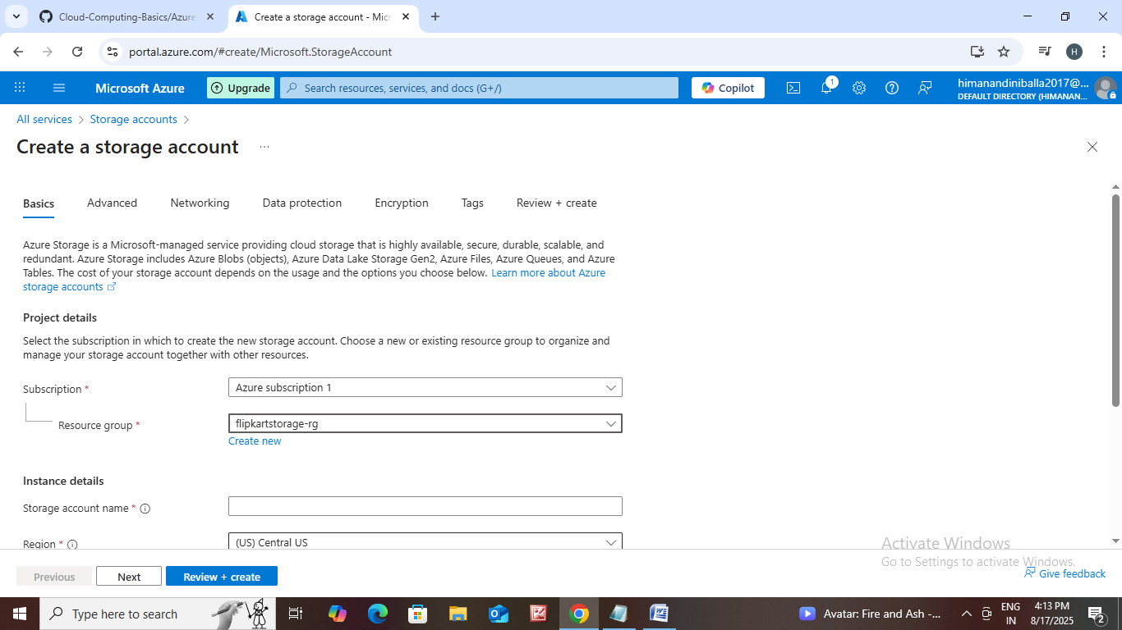

* Subscription : Pay as you go (or)

Free trail means azure subscription1

* Resource group : Create new resource group.

Take an example of online

Shopping apps like flipkart,

Amazon, meesho.

Meesho-rg

* Storage account name : meesho storage
* Region : choose region
* Performance : Standard - general purpose

Premium – Recommended for

Low latency scenarios.

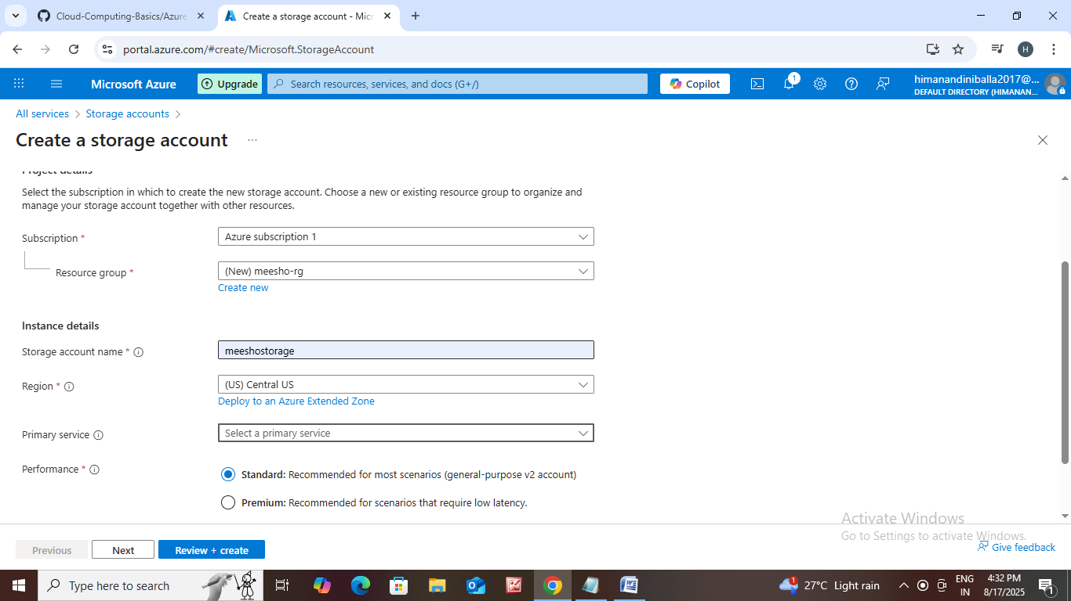

* Redundancy : 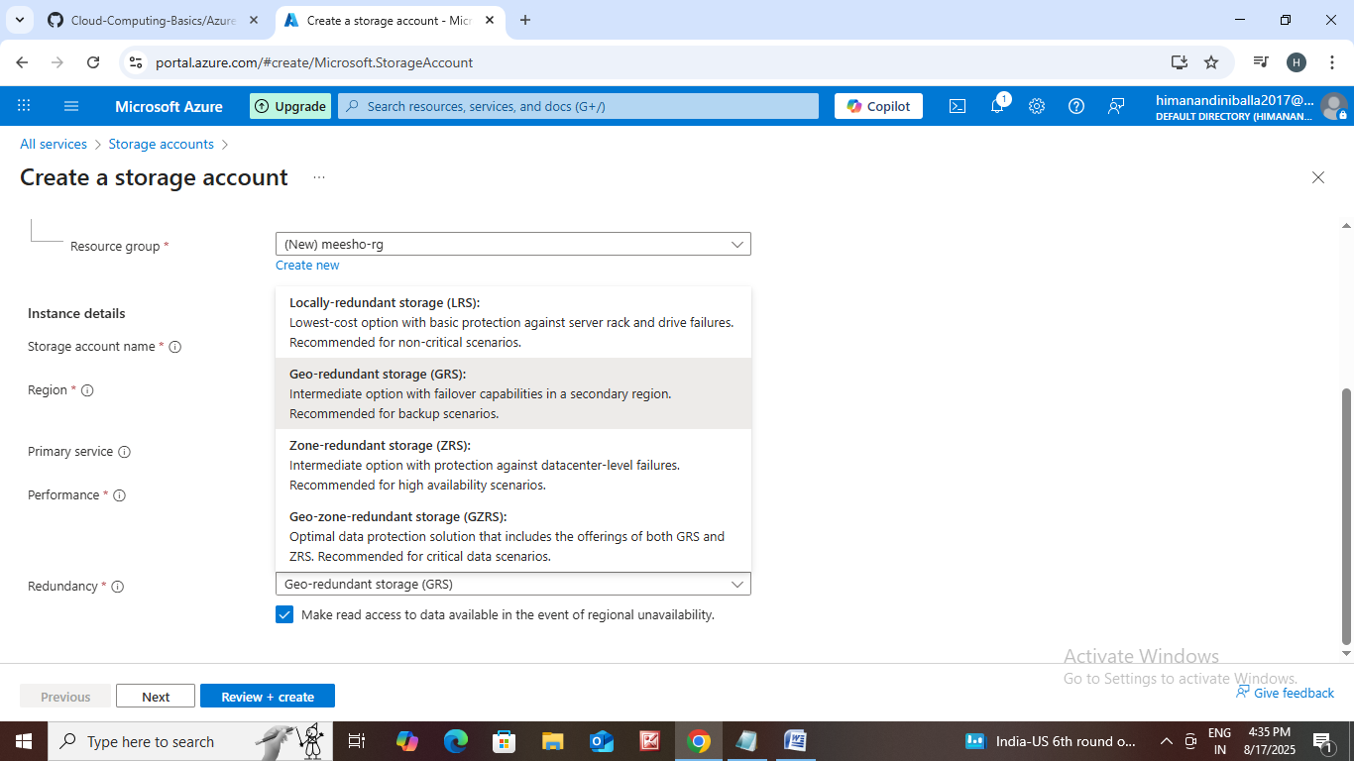

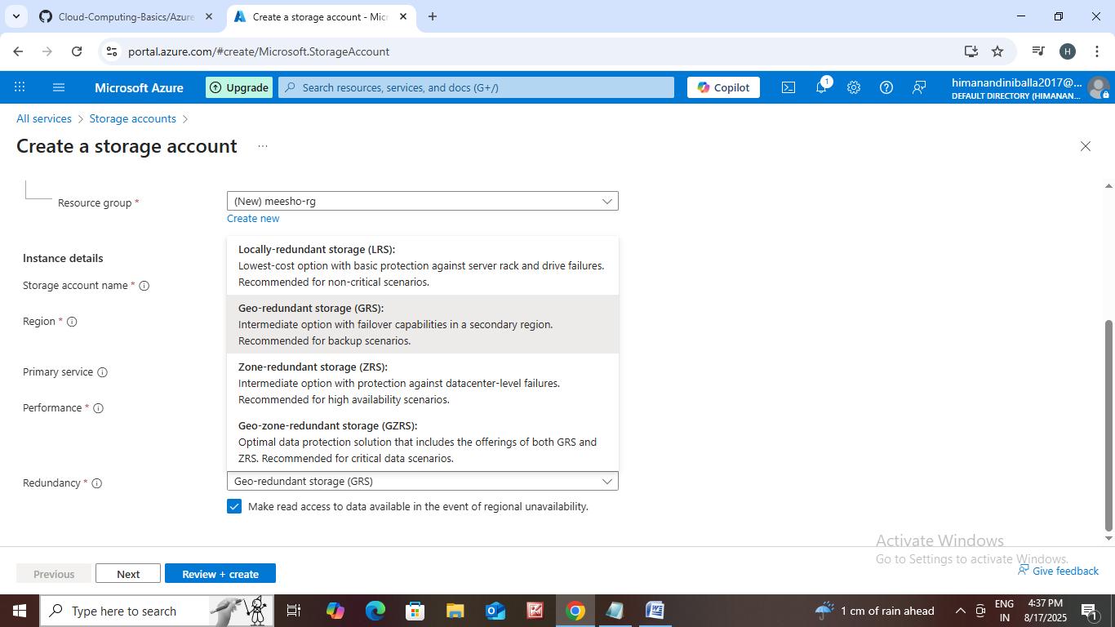

* Click next.

Advanced

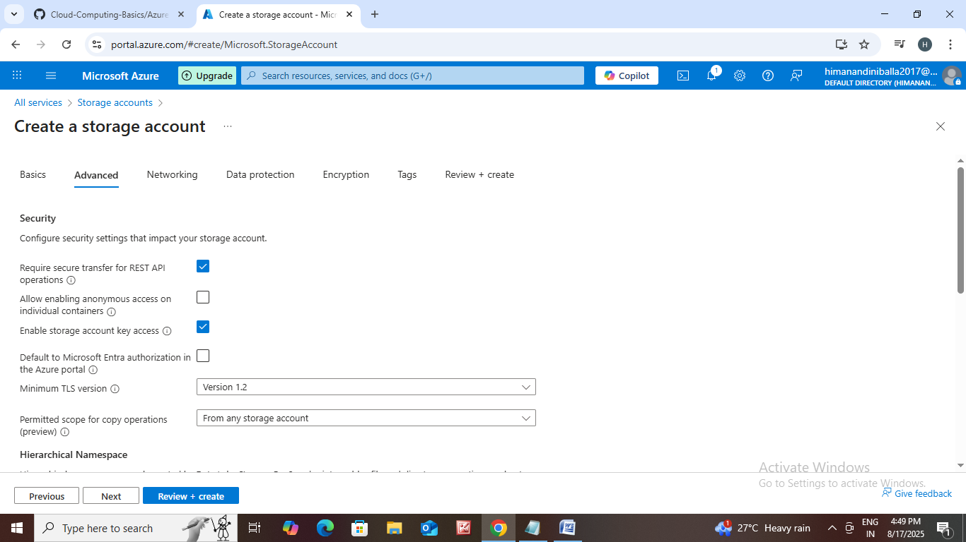

* Allow storage access key.
* Access tier : Hot, cool ,cold

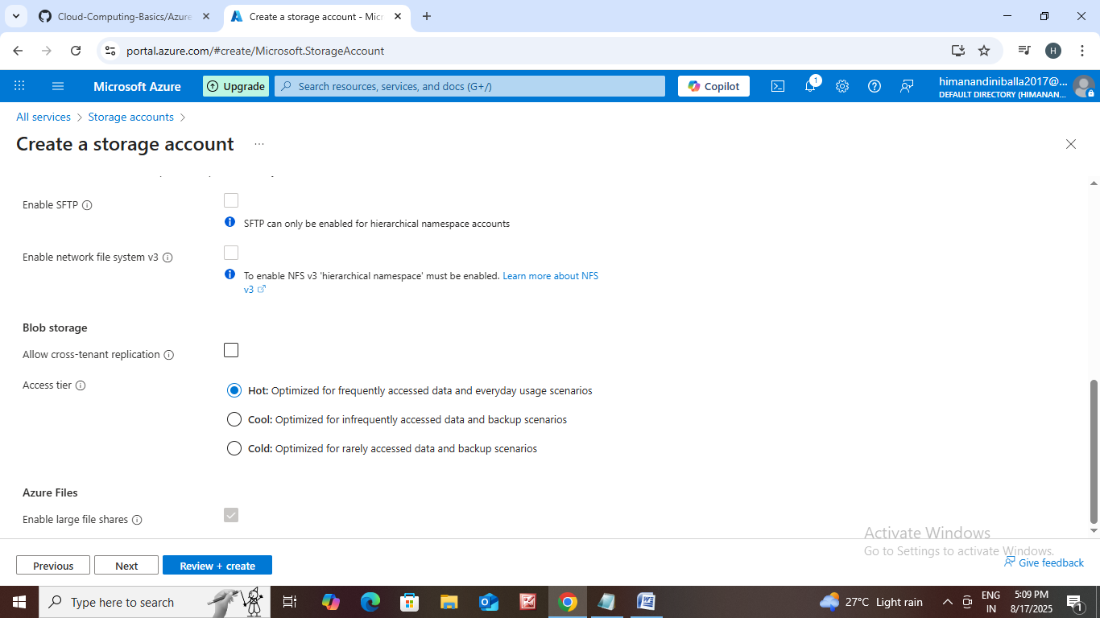

Networking

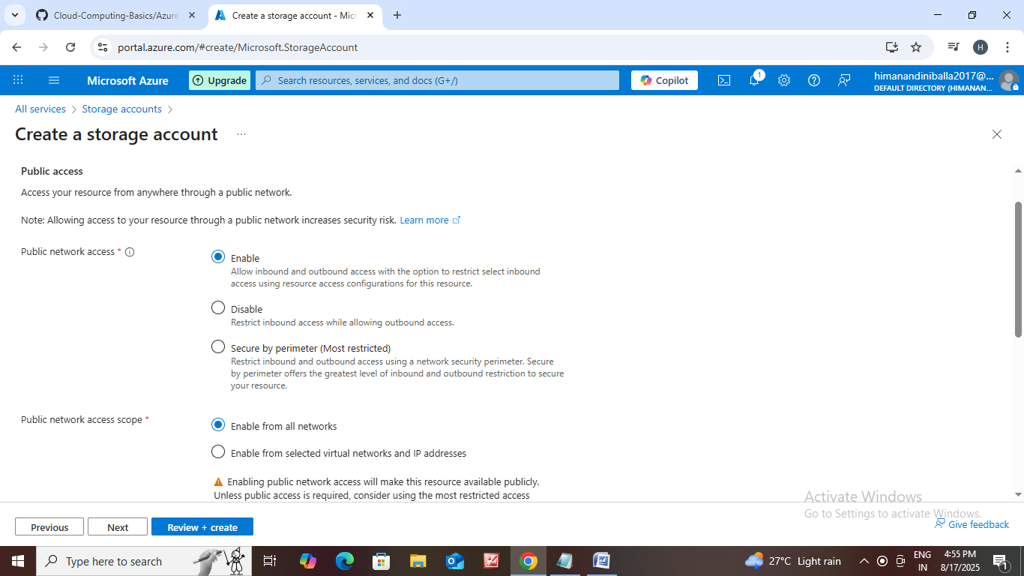

* In public network access choose enable or disable, secure by perimeter.
* In public network access scope choose enable from networks or enable from selected virtual networks and ip addresses.

Data Protection

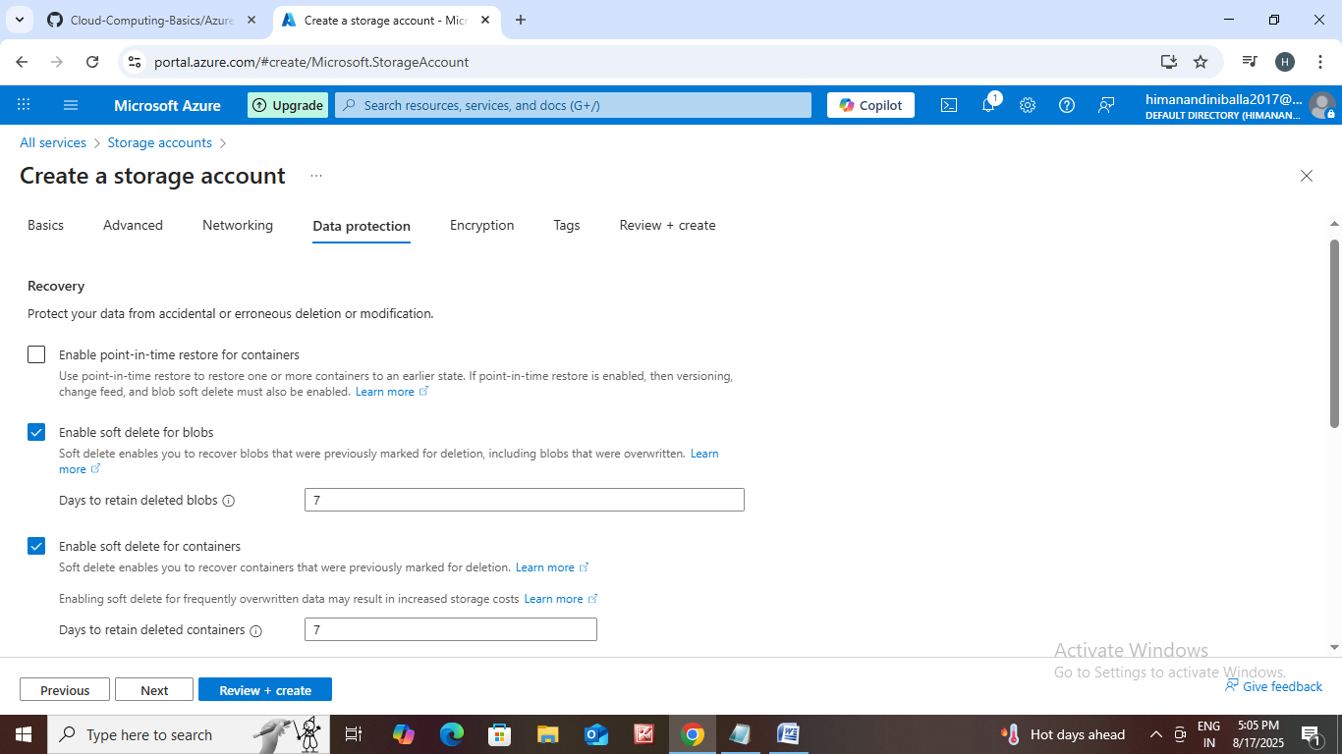

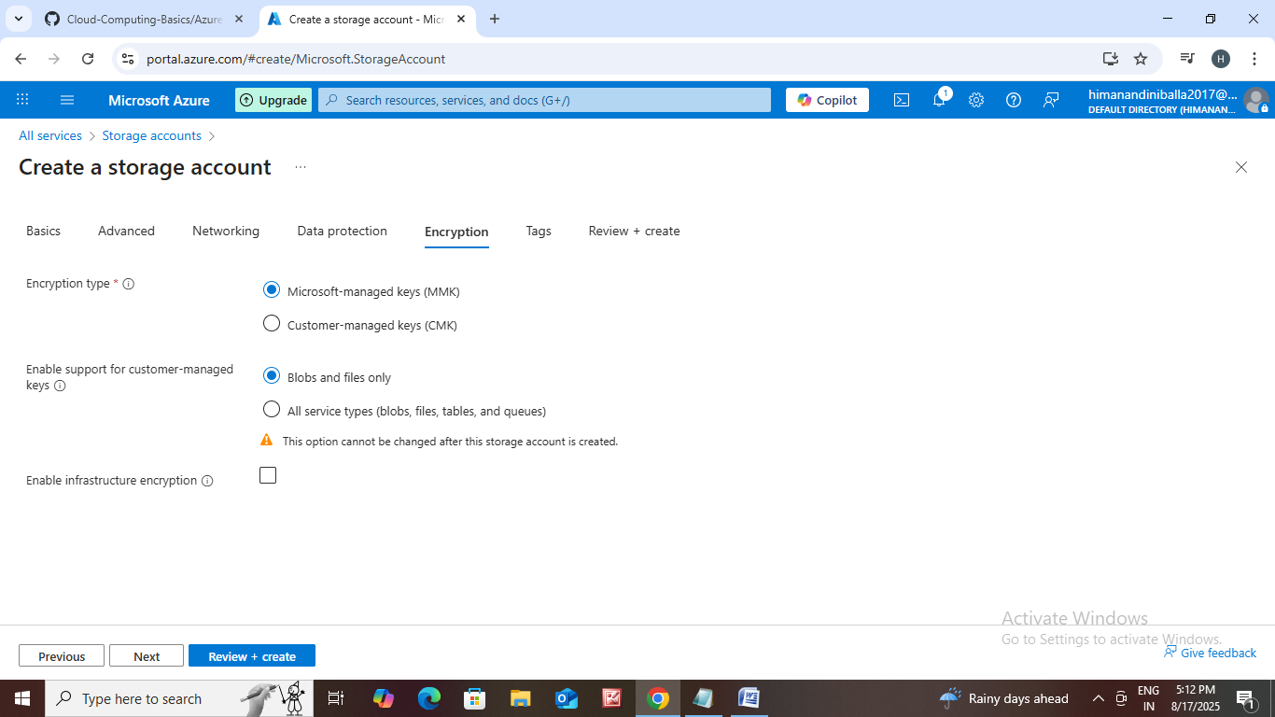

Tags

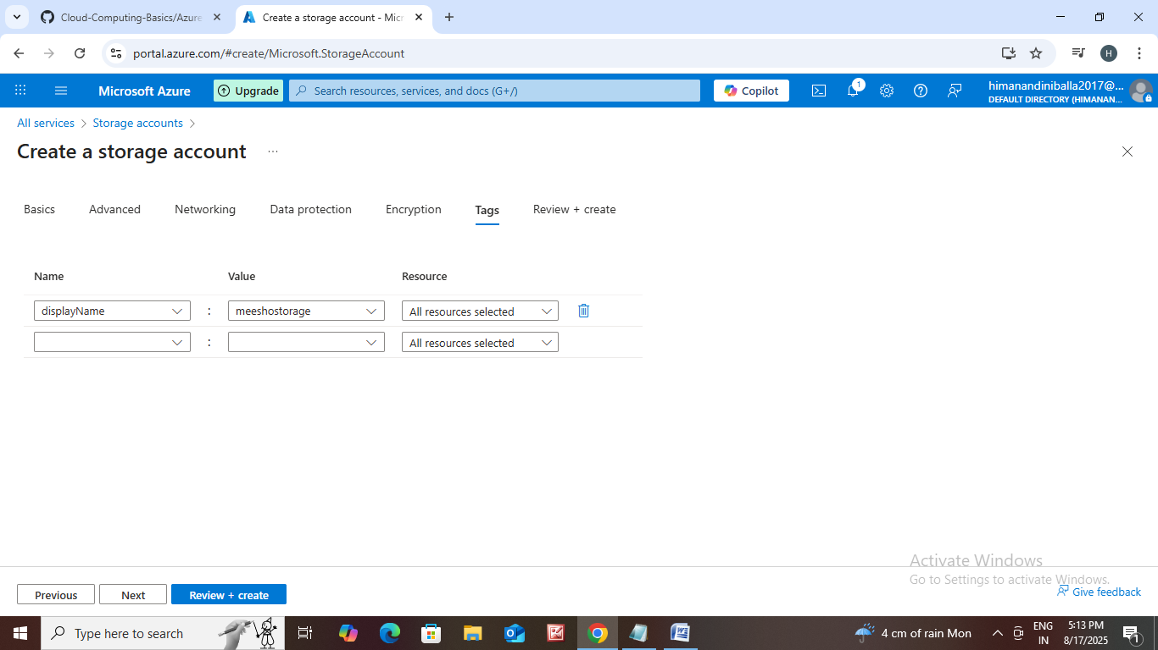

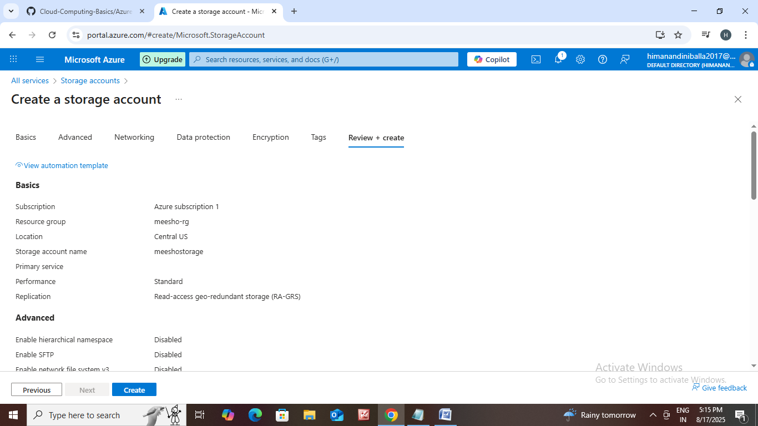

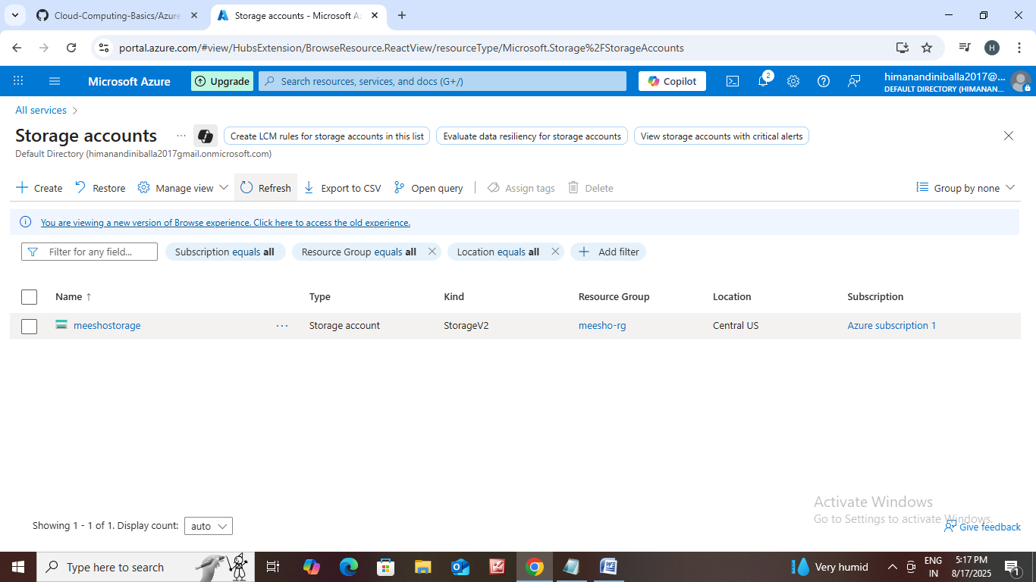

* Then storage account is created.

subscription

Meesho-rg

Key

Meesho storage

us usu us

.

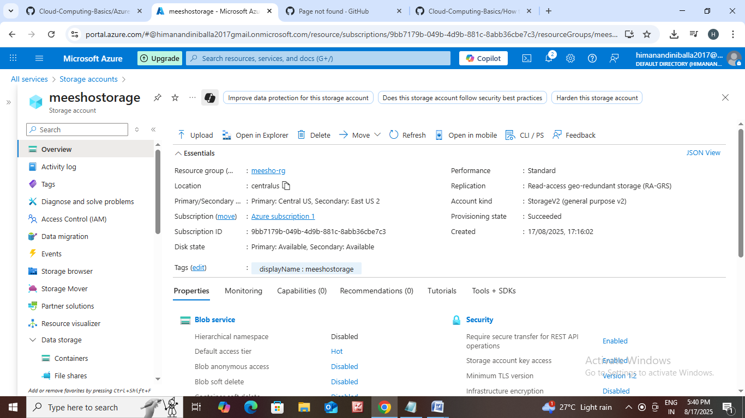

Tags : Tags in Azure are key-value pairs that act as metadata for your resources.

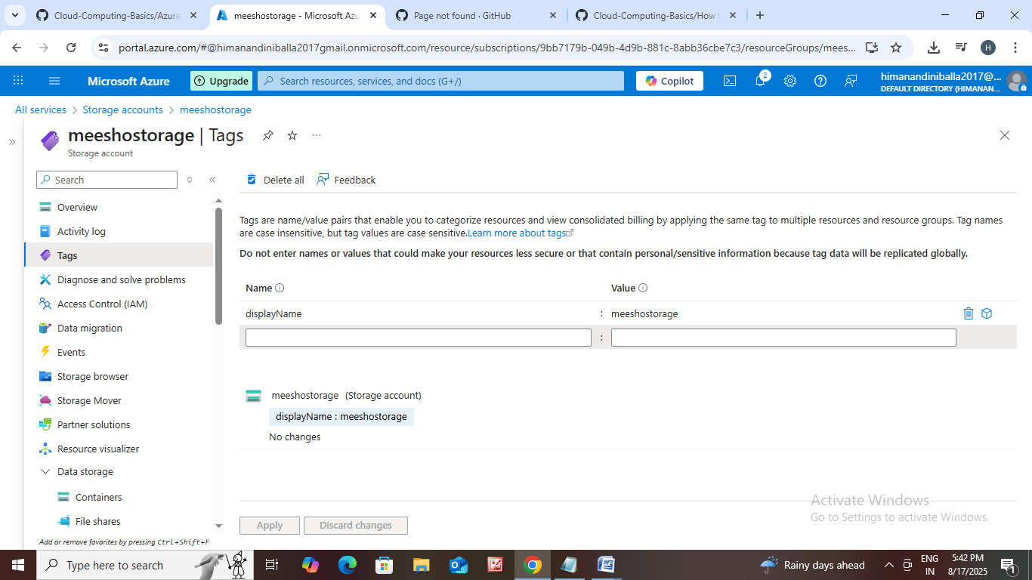

Diagnosing and resolving problems : To help users troubleshoot issues with their Azure resources without requiring extra configuration or billing costs.

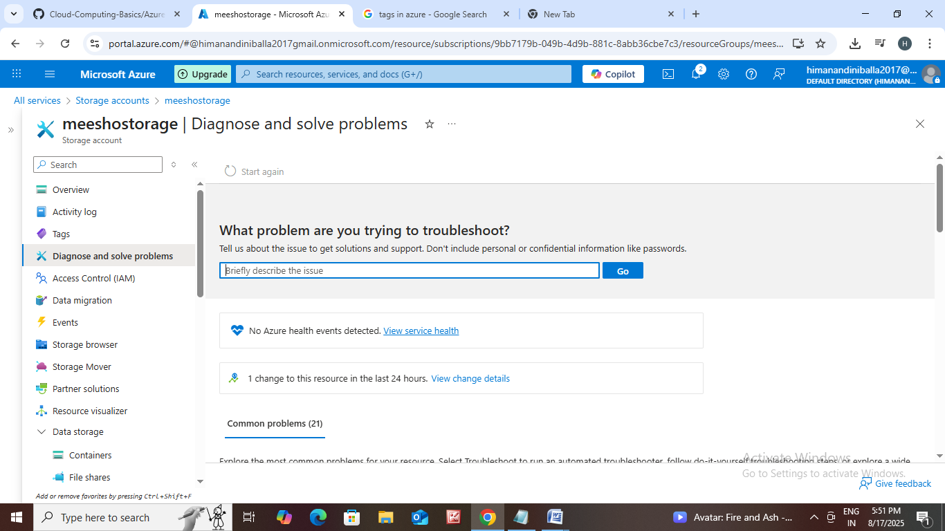

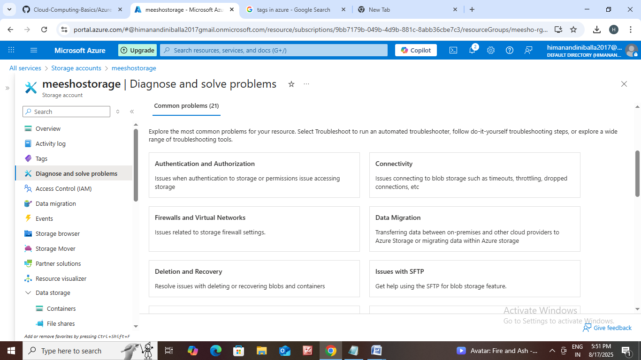

Access Control (IAM) : Identity and Access Management (IAM) in Azure focuses on securing your Azure resources by managing who has access to what resources and what actions they can perform. It's a critical component of cloud security, ensuring that only authorized users, groups, and services can access your applications and data.

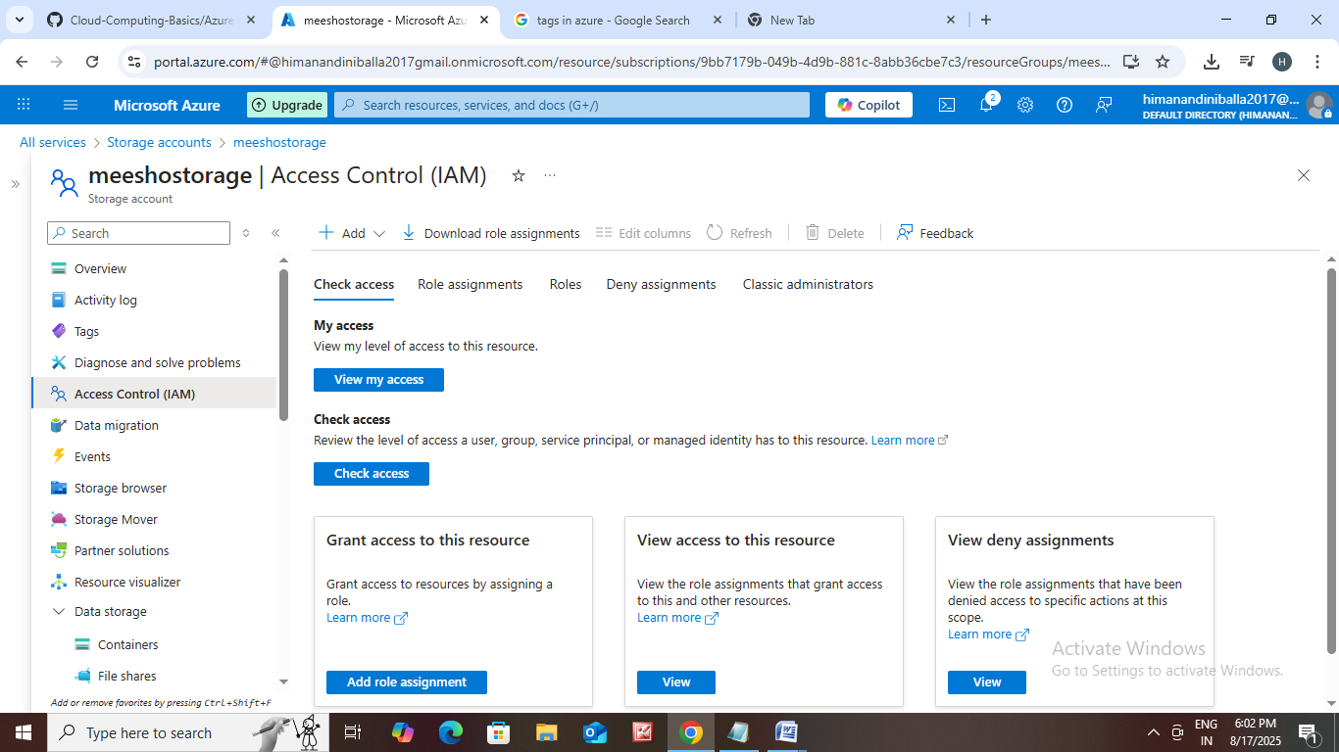

Data Migration: Data migration is the process of moving digital information from one storage system, database, or application to another.

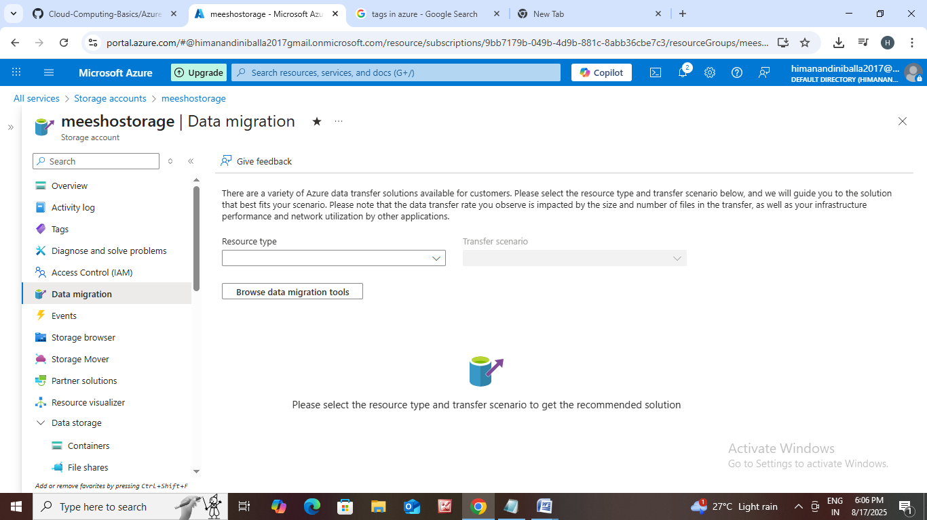

Event : something that happens within a system that needs to be communicated or reacted to by other parts of that system or by other applications.

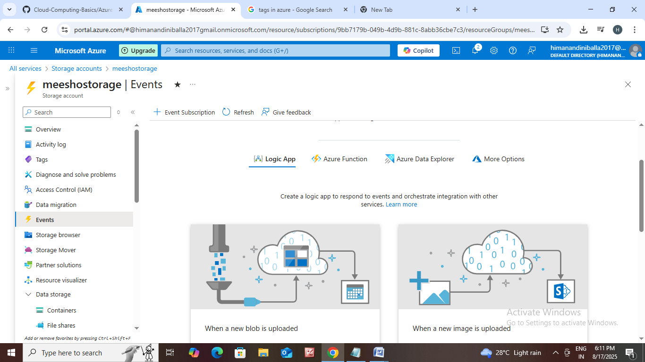

Storage Browser :  It provides a basic interface for viewing and performing fundamental operations on your storage resources, such as creating and deleting containers or file shares, uploading and downloading files, and browsing contents.

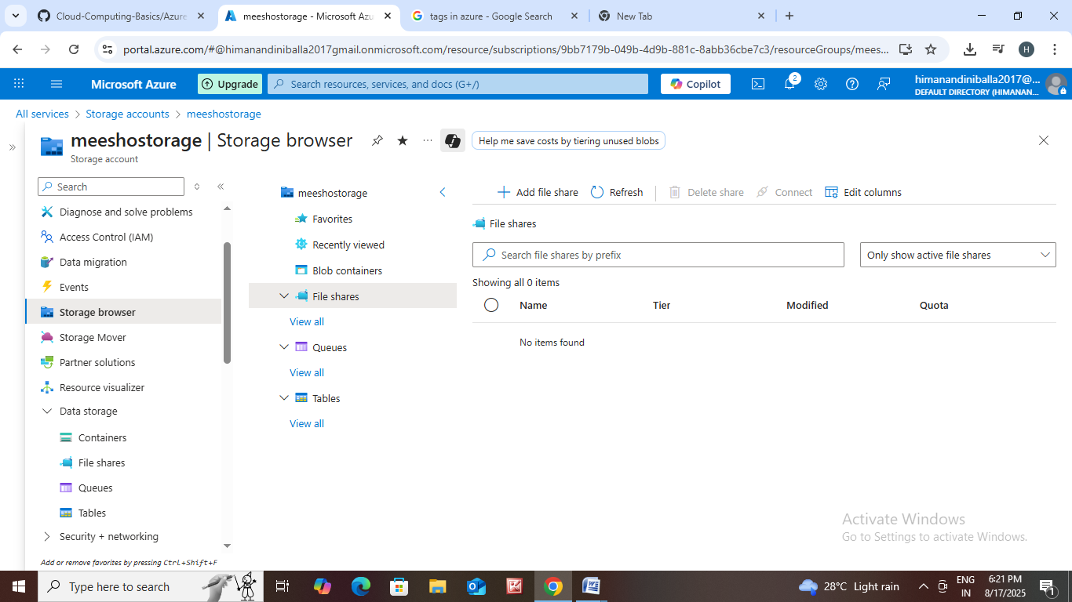

Storage mover :

Azure Storage Mover is a fully managed, hybrid migration service designed to simplify and accelerate the process of moving files and folders into Azure Storage.

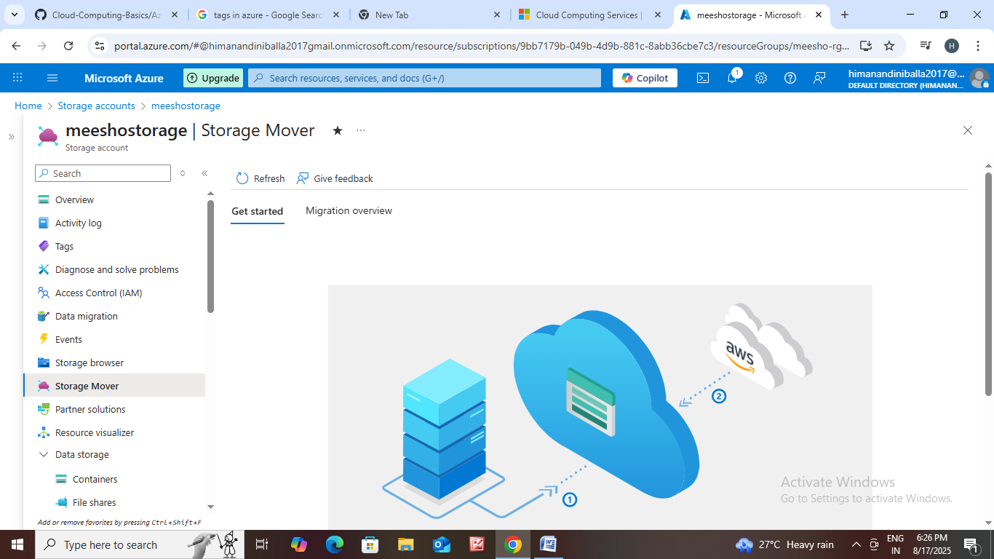

Partner Solutions : Microsoft Azure boasts a rich ecosystem of partner solutions, which are products, services, and expertise offered by independent software vendors (ISVs), system integrators (SIs), managed service providers (MSPs), and other partners to complement and enhance the Azure platform. These solutions provide diverse capabilities to address various business needs, extending the functionality of Azure and offering tailored solutions for specific industries or use cases.

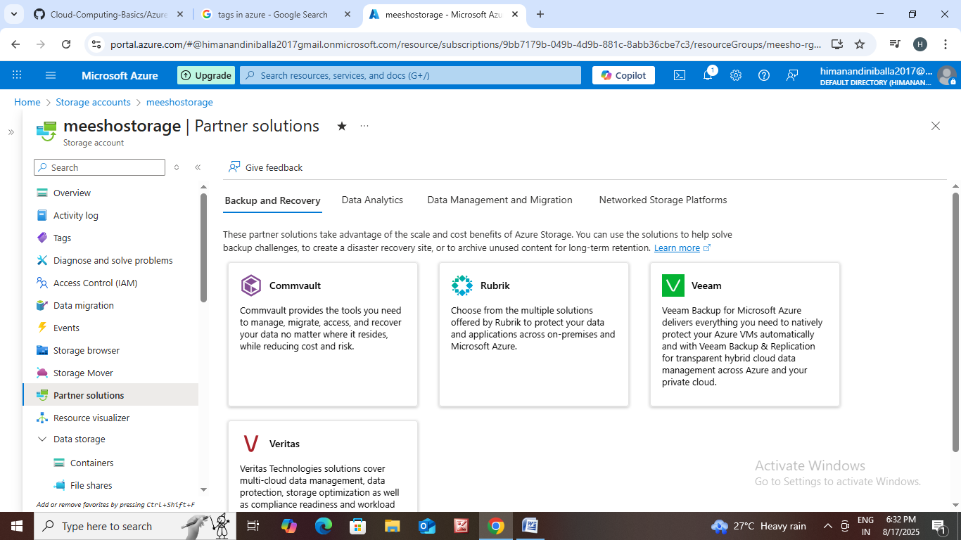

Data Visualizer : Azure offers a rich ecosystem of tools and services to visualize your data, helping you gain actionable insights and make informed decisions.

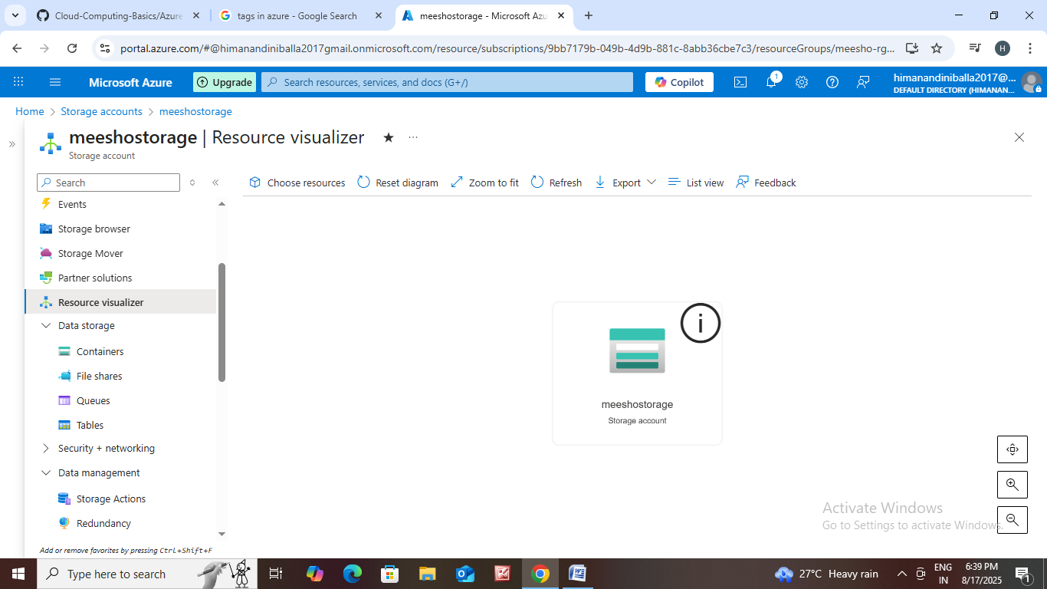

Data Storage : Azure provides a wide variety of storage services tailored to different data types, performance needs, and access patterns.

* Containers - Blob storage is Azure's object storage solution for storing massive amounts of unstructured data.
* File Shares -    Azure Files offers fully managed file shares in the cloud accessible via SMB, NFS, and the Azure Files REST API.
* Tables -  Azure Table storage is a NoSQL store for structured data without a schema. It is a key/attribute store for large quantities of structured, non-relational data.
* Queues. -  Azure Queue Storage is a messaging service designed for reliable asynchronous messaging between application components. It stores messages up to 64 KB for later processing.

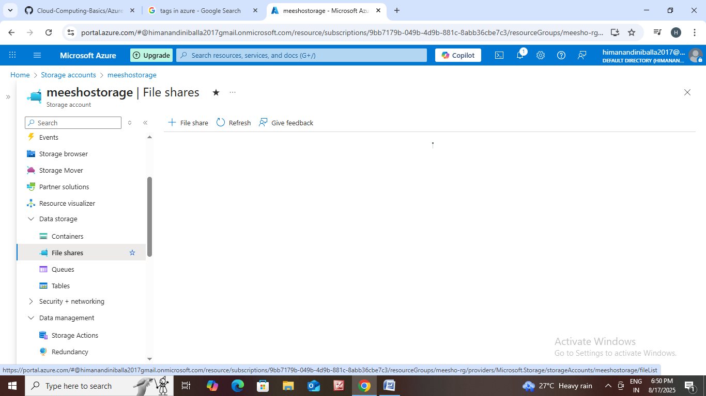

How to create an container ?

Go to Data storage click on containers

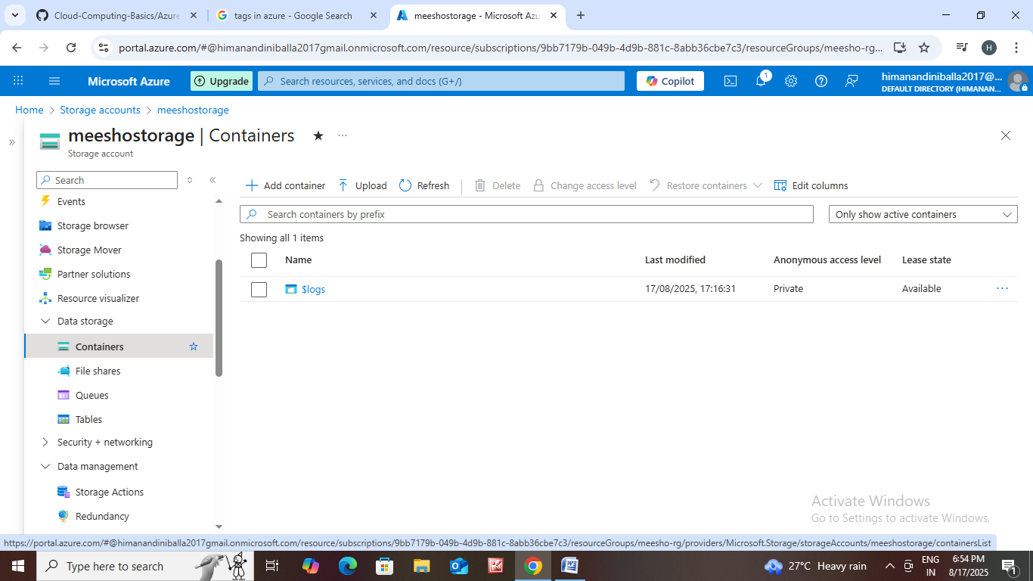

Click on add container.

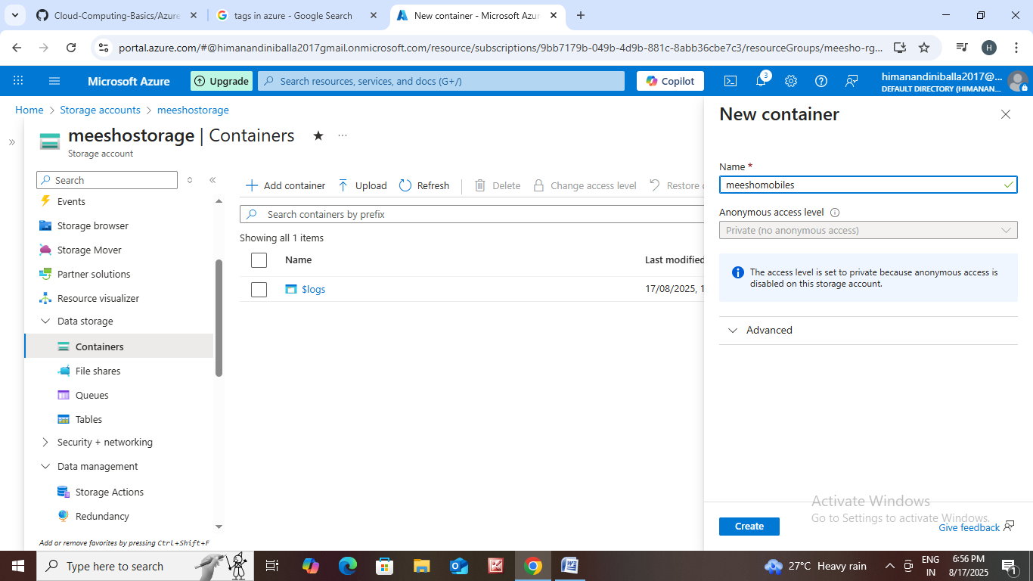

New container:

Name : meeshomobiles

Then create

